Broadband Access in California: An Economic Imperative

A White Paper Prepared by the Central Coast Broadband Consortium



The Need

There are few technologies that hold as much transformative economic power as fiber optic cable. Capable of carrying vast amounts of information, these lit pieces of glass are now the backbone to the global economy. Access to this resource is the single largest factor in a community’s ability to provide comprehensive services -- and employment -- for its citizens.
Access to this resource has implications across almost all area of public policy. High speed networks are a defining factor in the performance of public agencies, healthcare providers, schools, universities and technical colleges as well as research institutions and private employers.
This white paper is intended to illustrate how this resource has implications across all of society and to make the case for increased investment and support of the development of a more robust broadband grid for all of California through a limited number of smart, high impact, but low-cost policy developments; namely the statewide development of a “dig once” policy and an administrative directive to record where and how internet resources are placed into the public right of way.
Another aspect to encouraging investment in this sector is to encourage private sector competition. A healthy competitive marketplace for communications services is required to assure cost-based pricing and to forestall the temptation of monopoly service providers to price this resource out of the reach of many Californians. If the barrier to entering the market is prohibitive, incumbent providers can raise prices far above costs to the determent of the consumers.
To build our local economies (which in the aggregate create the 8th largest economy in the world), we need better infrastructure, particularly faster and cheaper broadband access for businesses, institutions and residents. It will require a coordinated and sustained cooperation between public and private partners to help develop these resources in cost effective and efficient ways. More holistically, it will require a reframing of the way in which local governments think about communications infrastructure.
As an economic development engine, broadband can help sustain and expand the region’s businesses so that they can reach global markets, actualize cost savings by government agencies, improve public safety communications, provide health and medical services at lower costs, offer workforce development to unemployed and underemployed residents to learn new job skills, and prepare local youth with the technology skills essential for their future -- all for a very limited investment of public sector dollars and administrative overhead.

 | Fiber vs. copper. The orange conduit contains 72 fiber strands, one of which can transmit as much data as the entire copper bundle in the black conduit.

The Ask

This white paper is a primer on the basics of internet infrastructure and how Cities, Counties and other public agencies can make to encourage the development of a more robust broadband infrastructure without dedicating a massive amount of fiscal or human resources. The intention of this paper is to surface a few key areas where statewide policy, either through the legislature or the California Public Utilities Commission can encourage additional development of broadband resources. Guided by industry, state and federal efforts, the Central Coast Broadband Consortium and its 40+ member communities would like to formally request the development of a statewide “dig once” once policy to be combined with an administrative effort to catalogue existing broadband resources.

The Tubes

The internet is not a “cloud” or a place, it is a physical thing. While the technology that governs international digital communication is mind boggling in its complexity, the physical resources that create it really are, as former Alaskan senator Ted Stevens once said, “a series of tubes.”
Whether copper, cable or fiber, the digital services we all utilize, from phone calls to web sessions all resolve back to a series of interconnecting network assets which can route a piece of information from our thumbs to a global audience.
There are three parts to the internet, the “backbone,” the “middle mile,” and the “last mile.” The backbone is a global network of high fiber-optic trunks run by a small number of multinational providers. These data routes aggregate vast amounts of information and distribute it across continents and under oceans to a number of global hubs in places like Frankfurt, Palo Alto and Tokyo.
From there, global traffic is broken down into “middle mile” routes, whose closest analogy is a regional road, that flow from a metropolis to smaller centers of population. From there, the “last mile” delivers service to individuals, institutions and businesses. It is in these latter two categories that local communities need to focus their efforts to secure resources for their citizens.

 | 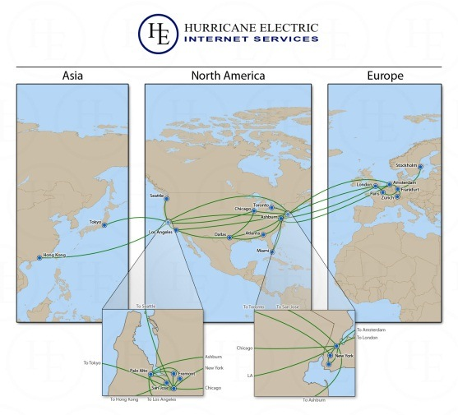
Visualization of global internet traffic from a 24-hour period. Image courtesy of the OPTE Project | Map of major backbone connections globally. Image provided by Hurricane Electric, a backbone service provisioning company from Fremont, CA

The Investment Conundrum

Our telecommunications networks are, with limited exception, the property of private concerns. As such they are built and deployed where the market demands it. While this makes perfect sense economically, it has placed large swaths of California at an economic disadvantage.
The Central Coast is, in many ways, a model of the economic inequality that faces communities without robust and redundant connections to broadband infrastructure. Huge swaths of our tri-county region feature a challenging topography of coastline, mountains, and farmland which are not well served by current providers, and there is a significant amount of area where no service is available at all.
Access to broadband is extremely limited. Large swaths of southern Santa Cruz and Monterey Counties, and nearly all of San Benito County is severely underserved -- which has negative consequences for businesses hoping to locate or expand regionally. This in turn is reflected in the region’s labor market, which has struggled throughout the “great recession” which began in 2008. More distressingly, the region has lost connectivity several times in recent years, including during the emergency response to the Big Sur fires of 2008-09.
After the boom (and bust) of fiber builds in the 1990s and early 2000s, telecommunications providers have focused their capital budgets on wireless services to capture revenue from the explosion of mobile telephony, at the expense of further investments or upgrades to existing local fiber loops. According to the OECD Communications Outlook (published biannually), telecoms capital expenditures peaked in early 2000 and has started to decline. One paper commissioned by Federal Communications Commission in 2009 authored by Robert C. Atkinson & Ivy E. Schultz estimated that capital expenditures have dropped from $59 to $51 billion between 2008 and 2009.
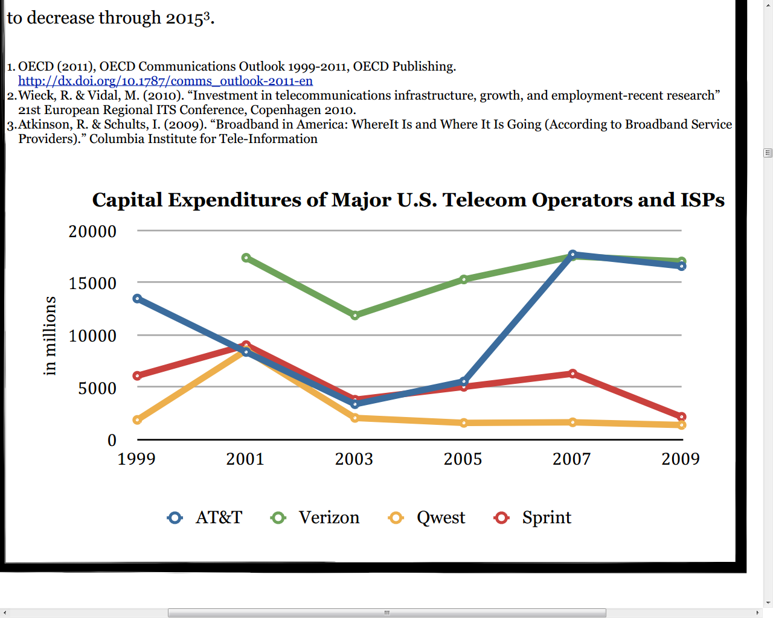 | Controlling for deployment of wireless assets, the figures for backbone investment have decreased even further. Image from OECD Communications Outlook 1999-2011, OECD Publishing

Faced with these economic realities, and facing significant pressure to create stable regional employment in a variety of industries, it is incumbent upon local jurisdictions to do everything in their power to lower the barriers to entry for the deployment of additional broadband resources, but the patchwork of local and state regulations and rural / suburban orientation of our communities has presented a barrier to entry to private providers – a situation that could be aided by some guidance from state policymakers.

Dig Once: A Common Sense Approach to Broadband Development

One of the major costs in building out middle mile and last mile broadband infrastructure is associated with the cost (and administrative hurdles, including public notice and approval of local jurisdiction) associated with opening a street and putting privately owned and/or operated utilities into the public right of way.
Given that a number of communities have a very impacted subterranean footprint, with legacy telephone and utility lines competing for space with municipal utilities, water and wastewater pipes, it is the responsibility of public works and municipal utilities directors across the state to carefully monitor how and where telecommunication infrastructure is deployed.
One sensible approach to encouraging coordination of street cuts and preserving the public investment in the transportation infrastructure has been developed by the City of Boston. The Public Improvement Commission and Office of Telecommunications administer a “dig once policy” whenever the street is opened, particularly when that street bisects a commercial or industrial zone or a community anchor organization.
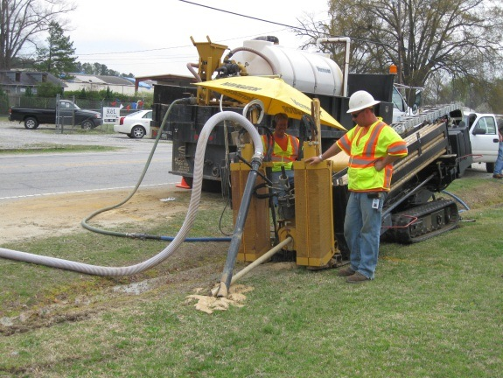 | 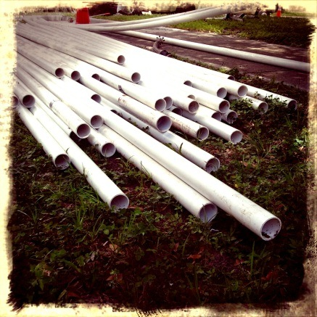
A worker installs subterranean conduit and fiber.  Image courtesy of the National Telecommunications Infrastructure Administration. | Simple PVC pipe.  This is what our economy depends on.

A smart “dig once” policy requires that a telecommunications provider will, in the process for applying for access to the public right of way, allow the jurisdiction in question to catalogue the planned run in their internal databases, then notice all other known telecommunications and cable providers in order to coordinate in the placement of conduit beneath an existing street.
As a final step in the process, the municipality, also places additional “shadow” conduit along the run, planning for the eventual deployment of additional telecommunications resources as demand increases in future years for utility, cable, communications or internet service. This final “shadow” conduit, which is deployed empty is owned and maintained solely by the public agency and can later be rented as needed to communications providers.
This measure also has implications for other investments in public infrastructure. Every street cut reduces the strength of a road dramatically. Given the limited amount of funds available in the foreseeable future for public infrastructure, it is imperative that we make every effort to preserve and protect those investments.

Why Add Conduit? It Creates New Revenue for Local Jurisdictions

Codifying this activity as a best practice at the state level will have a huge impact in the development of future broadband resources in California, open new markets and enable untold amounts of economic activity. This policy has economic implications for local jurisdictions, as it creates a resource which can be rented on an annual basis to communications providers. As revenue is extremely tight for municipalities in California, simply raising awareness of this potential revenue source may be helpful.
While we believe developing conduit should be part of a jurisdiction’s long term economic development strategy, many communities are not aware of the potential revenue source that they are holding.
It is important for communities to offer access to all providers equally. The Federal Telecommunications Act of 1996 recognizes that communities will want to capture some remuneration for access to their right of way, and stipulates that they may “require fair and reasonable compensation from telecommunications providers, on a competitively neutral and nondiscriminatory basis, for use of public rights-of-way ” (Sec. 253 (c)).
In California, the CPUC set rates for pole attachments and conduits for Investor Owned Utilities, such as Pacific Gas & Electric. The current rate set by the CPUC is $2.50 a pole per year. However, the CPUC has no authority over municipal-owned utilities. Jurisdictions that own conduit are free to structure leases with communications service providers as they see fit. Simply making these local leaders aware of this resource would be a huge spur to development of local conduit networks.
 | 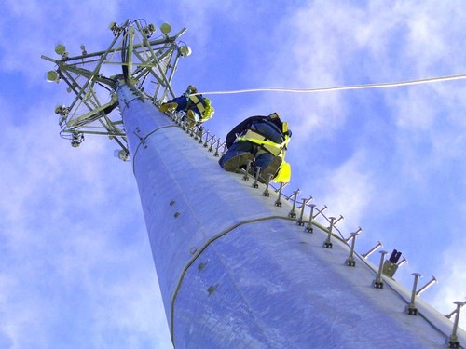
Fiber Bundles: Each of the these strands can carry 80 wavelengths of gigabit traffic | Unified communications: Fiber and Cellular networks are one in the same

Annual per-linear-foot charges range from less than $1.00 to over $100 per foot, where the higher charges are either for the placement of multiple ducts or fibers or for occupying space in resources such as elevated highways or the New York/New Jersey Lincoln Tunnel.
In his excellent, and accessible “Tubes: A Journey to the Center of the Internet,” Andrew Blum details how conduit leases are a huge revenue source for Empire City Subway, which was founded in 1891 and now is a wholly owned subsidiary of Verizon. It has owned the franchise to build and maintain an underground system of conduits on Manhattan for more than a century. Its rates that haven’t changed in a quarter century and Empire charges $0.0924 per foot per month for a four inch diameter conduit . A two inch conduit runs $0.0578 a foot. A fiber run the length of Manhattan will cost about $4,000 a month -- if space if available.
The City of Milpitas, California charges $6,014.82 a year for the conduit it leases to XO Communications. Over a 30-year lease with XO, Milpitas will add $180,444.64 to their fund balances for a downtown fiber loop consisting of 17,861 linear feet at $0.10/ft, paid in-kind through 2013. After 2013, the City will receive $1/foot/year and the footprint will expand to 20,917 linear feet.

Dig Once Follows Best National Practices – And Best Financial Practices

In June of 2012, the White House directed the Federal Government to develop a “dig once” policy which echoes the structure and function of this policy. Specifically, the executive order called for: “the installation of underground fiber conduit along highway and roadway rights of way can improve traffic flow and safety through implementation of intelligent transportation systems (ITS) and reduce the cost of future broadband deployment. Accordingly, within 1 year of the date of this order the Department of Transportation . . . shall review dig once requirements in its existing programs and implement a flexible set of best practices that can accommodate changes in broadband technology and minimize excavations consistent with competitive broadband deployment.”
The Federal Highway Administration estimates that it is ten times more expensive to dig up and then repair an existing road to lay fiber than to dig a channel for it when the road is being fixed or built. According to estimates provided the House of Representatives by the Telecommunications Industry Association (TIA), “more than half of the costs of new broadband deployment are expenses that can be ascribed to the digging up and repaving of roadways. Further, it is estimated that the inclusion of broadband conduit in [roadway] construction would add less than 1% to the cost of the overall project.”

Show Your Work: Logging Resources

One of the persistent problems in the public sector is lack of human resources for long term data collection. Stretched by years of fiscal budget trimming, public works departments are struggling to keep up with existing workload. Under present conditions, securing a street opening permit may take some time, as individual plans must be laboriously checked and commented (typically on physical media) and then processed through public hearings.
Although public works departments require applicants to detail where they are excavating when building out communications infrastructure, the maps submitted by applicants are not supplied in digital formats. As a result, visibility into the physical plant that makes up the internet in this region is limited, which has negative impacts for communities hoping to foster economic development and plan for long range contingencies.
This issue is known and well documented by the California Public Utilities Commission, and addressing it is of the major areas of work underwritten by the California Advanced Services Fund.
There are several existing models of how this data can be collected and utilized. While this specific initiative may seem novel, it is based on long standing procedures developed to help coordinate between utility and communications providers and local jurisdictions.
Nearly all communities are members of Underground Service Alert of California; a nonprofit mutual benefit organization founded in 1976 that links the owners of underground service lines with potential excavators. USA’s joint noticing system is a simple way to increase coordination of construction amongst providers and is a model that can be leveraged and emulated.
The City of Seattle Washington has developed a specific Planning Analysis and Coordination Tool (PACT) to increase communication and collaboration amongst providers and the City for communication infrastructure upgrades. In PACT, providers and utilities are given a login to the tool where they are required to map out their future plans (over a three year period) and the City of Seattle provides a quarterly report on the projects that it intends to undertake, which includes the method and scope of each project (aerial, boring, trenching, ect.)
Like Seattle’s PACT program, the City of San Francisco also requires a high level of planning and coordination between providers to minimize impact on traffic flow and streets within the City. Placed behind a password-protected firewall, the City’s Five Year excavation planning tool leverages the municipal GIS to increase coordination between providers. Raising awareness of these innovative approaches will be essential for the future of the state’s economy.
Cataloguing existing broadband resources in electronic form could reduce administrative processing time, provide greater visibility into a community’s broadband infrastructure and inform a communities’ long range planning processes. It also has implications for disaster recovery and economic development. With the knowledge of where the resources are, steps can be taken to get them back online after an earthquake fire or flood. Access to fiber is a primary factor for companies when undertaking a site selection process. Insight into this will help economic development professionals attract and retain employers to California.
In the City of Santa Cruz, economic development professionals have noted a relationship between high-speed connectivity and commercial absorption. With the recent economic downturn, commercial vacancies have increased from 11% in 2007 to 16% in 2010. Yet in 2011, when Cruzio, the local ISP, offered office space with high-speed connectivity, they reached 93% occupancy in less than three months of opening a new 60,000 square foot facility on Cedar Street in downtown Santa Cruz. Meanwhile, two blocks away, the Cooper House--a mixed use retail/office building—has been mostly vacant since their last tenant, Light Surf Technologies vacated in 2008. The building’s connectivity is based on a share cable connection.

Conclusion

There are few policy areas so heavily weighted in the public’s benefit as the development of fiber optic resources for all of California. Like the railroad and interstate highway system, it is an epochal resource, and fosters entirely new kinds of interactions between people, communities and the world at large. The services enabled by fiber optic networks power our economy, support our shared public services and empower our doctors, teachers and public safety personnel to do their jobs more efficiently and with greater access to global talent, services and resources. If California is to remain the economic powerhouse of the western United States, it is our responsibility to continue to support smart, high impact, low cost policies like “dig once” to ensure that all Californians have access to the World Wide Web and other networked-enabled services.

